**Part 1: Complete the Addressing Table Documentation**

**Step 1: Use ipconfig to verify IPv4 addressing.**

a. Click PC1 and open the Command Prompt.

b. Enter the ipconfig /all command to collect the IPv4 information. Fill-in the Addressing Table with the

IPv4 address, subnet mask, and default gateway.

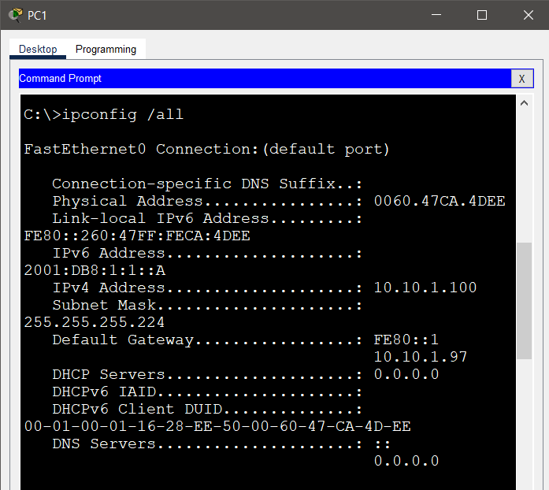

IPv4: 10.10.1.100

Subnet mask:255.255.255.224

Default gateway: 10.10.1.97

c. Click PC2 and open the Command Prompt.

d. Enter the ipconfig /all command to collect the IPv4 information. Fill-in the Addressing Table with the

IPv4 address, subnet mask, and default gateway.

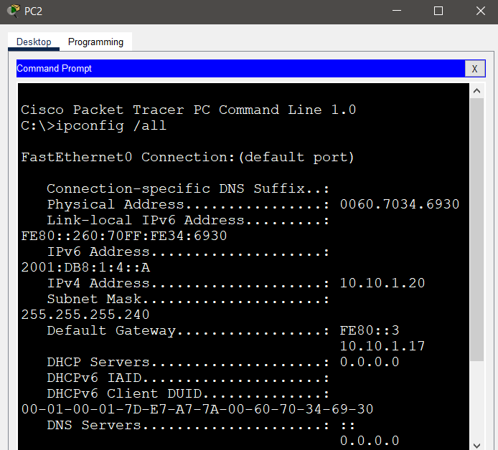

IPv4: 10.10.1.20

Subnet mask: 255.255.255.240

Default gateway: 10.10.1.17

**Step 2: Use ipv6config to verify IPv6 addressing.**

a. On PC1, enter the ipv6config /all command to collect the IPv6 information. Fill-in the Addressing Table

with the IPv6 address, subnet prefix, and default gateway.

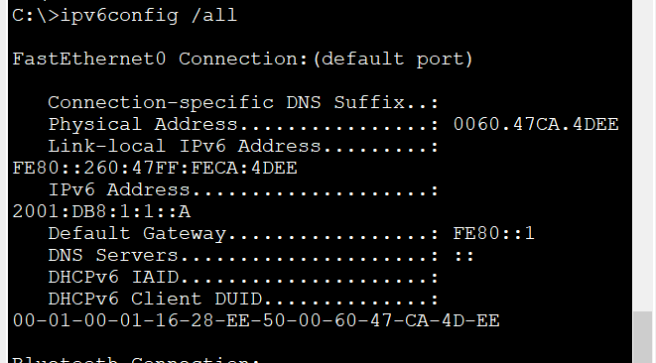

IPv6: 2001:DB8:1:1::A

Default gateway: FE80::1

b. On PC2, enter the ipv6config /all command to collect the IPv6 information. Fill-in the Addressing Table

with the IPv6 address, subnet prefix, and default gateway.

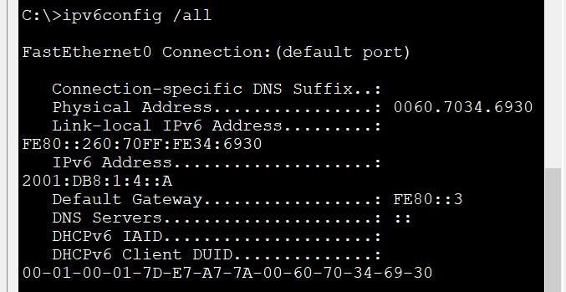

IPv6: 2001:DB8:1:4::A

Default gateway: FE80::3

**Part 2: Test Connectivity Using Ping**

**Step 1: Use ping to verify IPv4 connectivity.**

a. From PC1, ping the IPv4 address for PC2.

Question:

Was the result successful?

Yes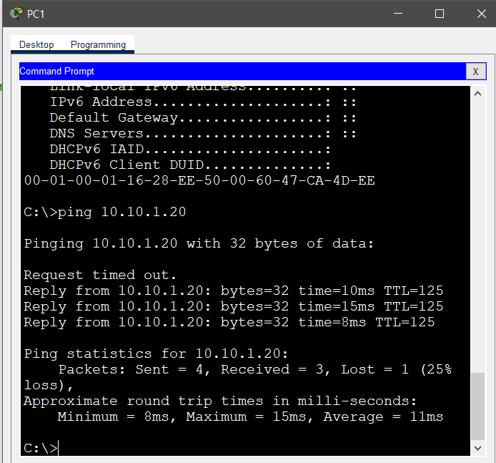

b. From PC2, ping the IPv4 address for PC1.

Question:

Was the result successful?

Yes

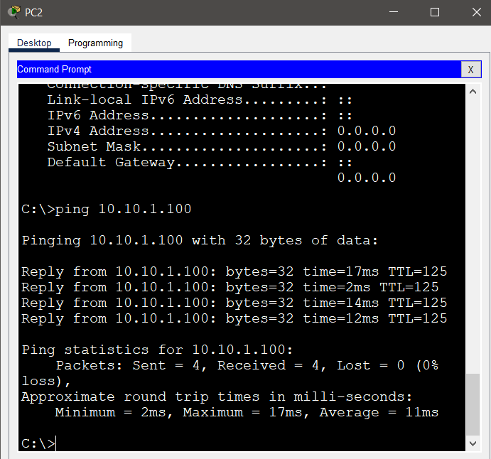

**Step 2: Use ping to verify IPv6 connectivity.**

a. From PC1, ping the IPv6 address for PC2.

Question:

Was the result successful?

Yes

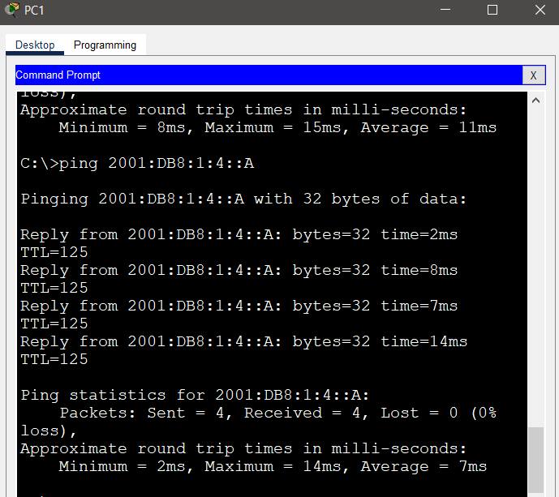

b. From PC2, ping the IPv6 address of PC1.

Question:

Was the result successful?

Yes

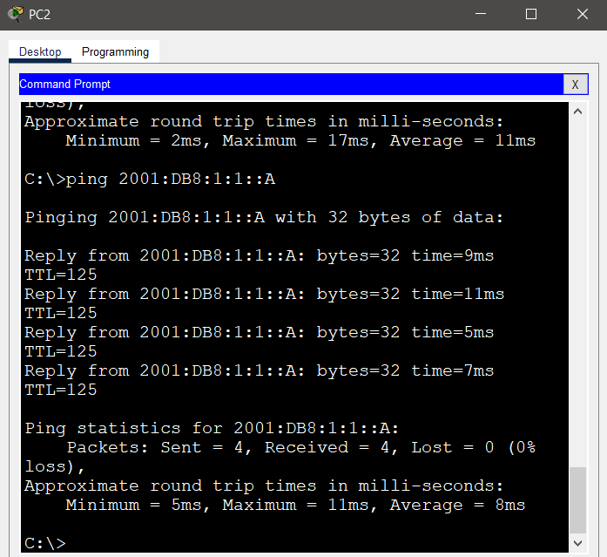

**Part 3: Discover the Path by Tracing the Route**

**Step 1: Use tracert to discover the IPv4 path.**

a. From PC1, trace the route to PC2.

PC> tracert 10.10.1.20

Questions:

What addresses were encountered along the path?

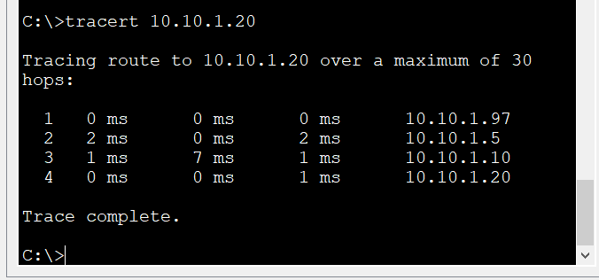

With which interfaces are the four addresses associated

The default gateway of three router along the path and the host destination.

b. From PC2, trace the route to PC1.

Questions:

What addresses were encountered along the path?

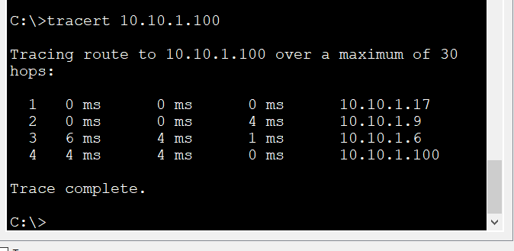

With which interfaces are the four addresses associated?

The default gateway of three router along the path and the host destination.

**Step 2: Use tracert to discover the IPv6 path.**

a. From PC1, trace the route to the IPv6 address for PC2.

PC> tracert 2001:db8:1:4::a

Questions:

What addresses were encountered along the path?

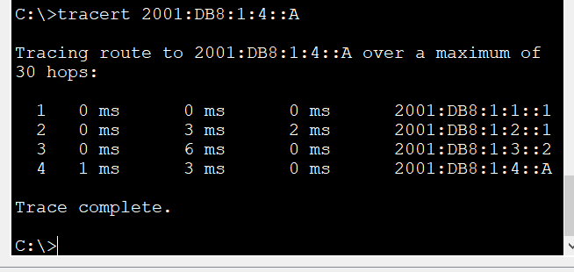

With which interfaces are the four addresses associated?

Three ipv6 of default gateway and the ipv6 of the destination host.

b. From PC2, trace the route to the IPv6 address for PC1.

Questions:

What addresses were encountered along the path?

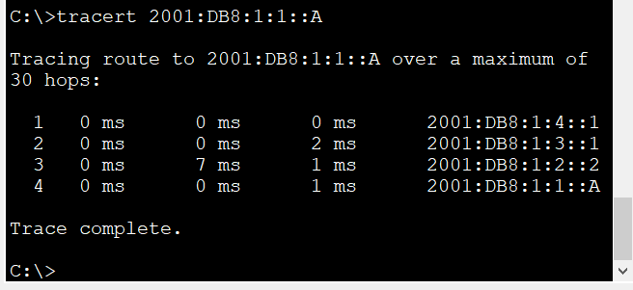

With which interfaces are the four addresses associated?

Three ipv6 of default gateway and the ipv6 of the destination host.